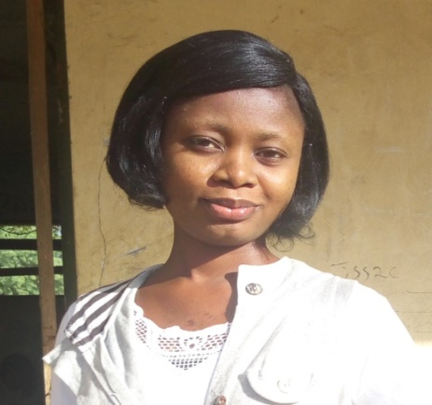
To obtain a position in a laboratory setting, which will utilize my education and experiences in clinical Microbiology
2014-2015: I T Student (Good Shepherd Medical Centre Anyigba)
2013-2017: fashion designer (Lady T Fashion and Design Institute) Anipe Qrt Ayetoro Gbede Kogi State.
2018-2019: NYSC (Army Day Sec. Sch. Zuru, Kebbi State) Biology teachers
EXPERIENCE
ODOFIN MERCY TOBI
MICROBIOLOGIST
OBJECTIVE
D
Figure 1FFFF
PROFILE

EDUCATION & QUALIFICATION
- Integrity and honesty
- Good interpersonal skills
- Ability to work effectively in a team
- Ability to work with little or no supervision
- Effective communication skills
2011-2017: Bachelor of Science in Microbiology (BS.c)
Kogi state University Anyigba
2004-2010: Secondary School Certificate Examination(SSCE)
T.A.C Ayetoro Gbede Area Secondary School
1996-2001: Sam-Bolo,Nur&Pri School Ayetoro Gbede ,Kogi- State

SKILLS
- Critical thinking
- Teaching strategies
- Communication
- Knowledge in microbiology
- Organized
- Creative lesson planning
CONTACT
PHONE:
08057177550, 07031318607
ADDRESS:
No. G98 Aduratedo Quarters Ayetoro Gbede Kogi state.
EMAIL: odofinmercytobi@gmail.com

REFEREES

SIR M.D.S ODOFIN: Kogi State Polytechnic Lokoja 08053429821
PROF O.J SALIU: Kogi State University Anyigba, 08167632642.
APOSTLE (BARR) FEMI ALEMEDE: Divine Intervention Ministries .
Dutsen Alhaji Bwari Abuja . 08034521888

