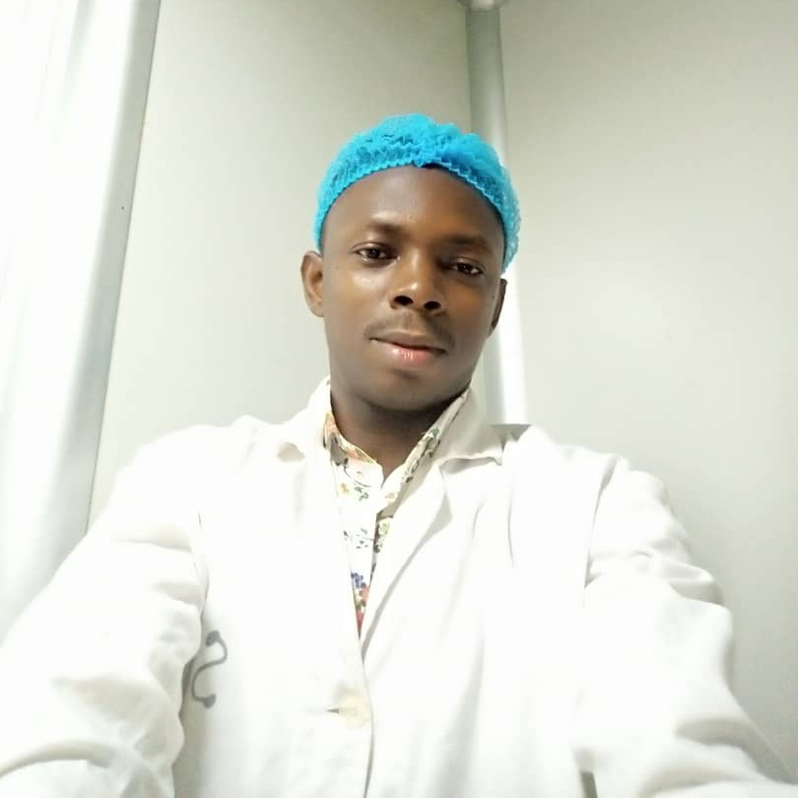 |  | ENECHE JACOB goddey  EDUCATION  National Youth Service Corps [Enugu State]  2017  [Discharge Certificate]  Kogi State University, Anyigba  2015  [B.Sc. Chemistry]  St. Peter’s College Idah, Kogi State  2009  [WASSCE, NECO]  WORK EXPERIENCE  Martglobal limited, Lagos (Polythene/Plastic Company)  2019-Date  Quality Control Officer  Diamond Bank Plc, Lagos  Process Associate (Operations)  2018  Michelle-Laboratories Limited, Enugu (Pharmaceutical Company)  2017{NYSC}  Quality Assurance/Quality Control Personnel  Greater Lokoja Water Plant  Industrial Training  2014

Profile
Nationality: Nigerian
Sex: Male
Marital Status: Single

Contact
PHONE:
08064179960, 09026430693
EMAIL:
enechejacob@gmail.com
12, Church Street, Pleasure Bus Stop, Oke-Odo, Lagos (Willing to relocate)

Hobbies
Researching
Reading
Travelling
Meeting New People

SKILLS
Self-confidence and desirous to learn.
Ability to work with minimal supervision.
Good team player with analytical mind.
Effective communication and problem solving skills.

RESEARCH
Investigation of Ethylenediaminetetra acetic Acid (EDTA) and Sodium Hexametaphosphate (SHMP) as Corrosion Inhibitor in Metals.
Effect of Some Local Addictive on the Chemical Constituent of Palm Oil

REFERENCE
Available on request

