OWOEYE SEGUN SAMSON BLOCK 7 FLAT 65, OTEDOLA JUBILEE ESTATE, OMOLE PHASE 2, IKEJA, LAGOS. Phone: 07039286166 E-mail:owoeyesamson93@gmail.com
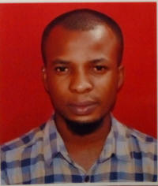
PROFILE
I am highly motivated, proactive, competent, meticulous about assigned tasks and capable of meeting deadlines, complemented by great ability to assume new roles if need be. I am a hardworking young man determined to bring in new ideas to foster greater organizational development and growth. I am seeking a suitable role that will enable me to harness my professional and interpersonal skills and provide a personal and professional challenge in promoting my career development.
CAREER INTERESTS
Clients’ relations, public relations, business development, product management.
KEY STRENGTH
- Excellent communication, negotiation, and profile management skills
- Excellent interpersonal relations skills
- Outstanding ability to work with wide range of clients and stakeholders
- Good team spirit
- Ability to work under pressure
- Oral and written communication
- Creative and problem solving abilities

WORKING EXPERIENCE
Broadcasting Corporation of Oyo State
Corps Member Oct. 2018- Oct. 2019
Turnerwright Company, Ojodu-Berger, Lagos State
Factory worker July2015- October 2015
EDUCATIONAL QUALIFICATIONS
University of Ilorin 2014 – 2018
B.A (Hons) Linguistics (Second Class Lower Division)

PROFESSIONAL QUALIFICATIONS
- Certificate in Human Resources Management 2019
INTEREST
Football, Research, Traveling and meeting people
REFEREE:
Available on request

